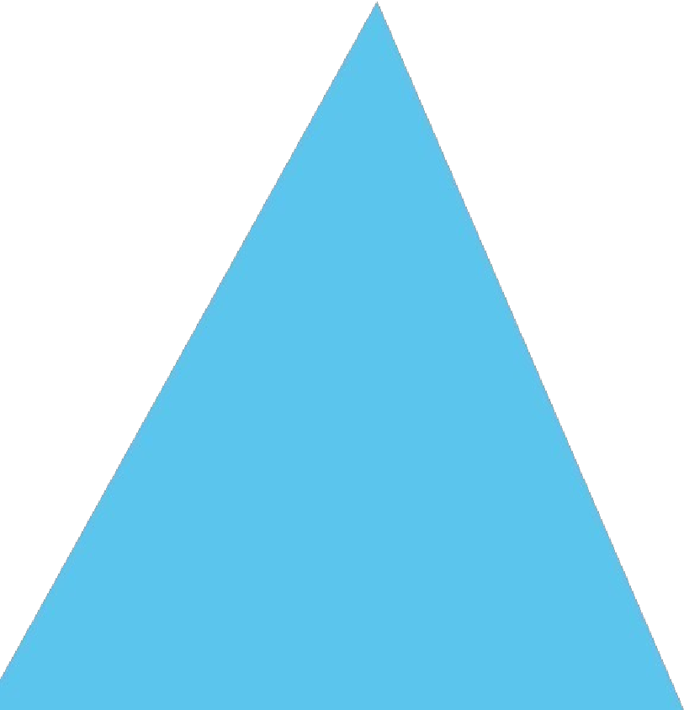



SUBMITTED TO:

SUBMITTED BY:

DANISH ZULFIQAR
REGISTRATION NO.:

FA21-BEE-042
SEMESTER-SECTION:

5-
B
COURSE:

EEE 462
Lab Report 03
BS Electrical Engineering
DR. DILSHAD SABIR
Artificial Intelligence
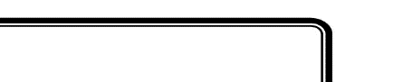
LAB # 3

Lab Activities:
Activity 1:
Consider a toy problem that can be represented as a following graph. How would you represent this graph in python?

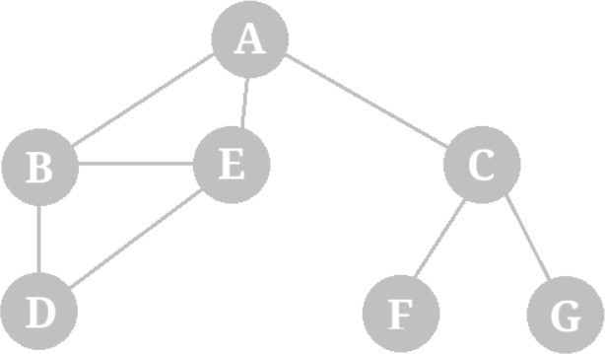
class Node:
def __init__(self, state, parent, actions, totalCost):
self.state = state
self.parent = parent
self.actions = actions
self.totalCost = totalCost
graph = {'A': Node('A', None, ['B', 'C', 'E'], None),
'B': Node('B', None, ['A', 'D', 'E'], None),
'C': Node('C', None, ['A', 'F', 'G'], None),
'D': Node('D', None, ['B', 'E'], None),
'E': Node('E', None, ['A', 'B', 'D'], None),
'F': Node('F', None, ['C'], None),
'G': Node('G', None, ['C'], None)}

Activity 2:
For the graph in previous activity, imagine node A as starting node and your goal is to reach F. Keeping breadth first search in mind, describe a sequence of actions that you must take to reach that goal state.
Solution:
Remember that in theory class, we discussed the following implementation of breadth first search.
Calling BFS() will return the following solution, ['A', 'C', 'F']

class Node:
def __init__(self, state, parent, actions, totalCost):
self.state = state
self.parent = parent
self.actions = actions
self.totalCost = totalCost
graph = {'A': Node('A', None, ['B', 'C', 'E'], None),
'B': Node('B', None, ['A', 'D', 'E'], None),
'C': Node('C', None, ['A', 'F', 'G'], None),
'D': Node('D', None, ['B', 'E'], None),
'E': Node('E', None, ['A', 'B', 'D'], None),
'F': Node('F', None, ['C'], None),
'G': Node('G', None, ['C'], None)}
def BFS():
initialState = 'A'
goalState = 'F'
graph = {'A': Node('A', None, ['B', 'C', 'E'], None),
'B': Node('B', None, ['A', 'D', 'E'], None),
'C': Node('C', None, ['A', 'F', 'G'], None),
'D': Node('D', None, ['B', 'E'], None),
'E': Node('E', None, ['A', 'B', 'D'], None),
'F': Node('F', None, ['C'], None),
'G': Node('G', None, ['C'], None)}
frontier = [initialState]
explored = []
while len(frontier) != 0:
currentNode = frontier.pop(0)
explored.append(currentNode)
for child in graph[currentNode].actions:
if child not in frontier and child not in explored:
graph[child].parent = currentNodE
if graph[child].state == goalState:
return actionSequence(graph, initialState, goalState)
frontier.append(child)
solution = BFS()
print(solution)
def actionSequence(graph, initialState, goalState):
solution = [goalState]
currentParent = graph[goalState].parent
while currentParent != None:
solution.append(currentParent)
currentParent = graph[currentParent].parent
solution.reverse()
return solution

Output:
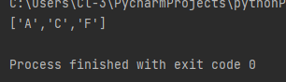

Activity 3:
Change initial state to D and set goal state as C. What will be resulting path of BFS search?
class Node:
def __init__(self, state, parent, actions, totalCost):
self.state = state
self.parent = parent
self.actions = actions
self.totalCost = totalCost
graph = {'A': Node('A', None, ['B', 'C', 'E'], None),
'B': Node('B', None, ['A', 'D', 'E'], None),
'C': Node('C', None, ['A', 'F', 'G'], None),
'D': Node('D', None, ['B', 'E'], None),
'E': Node('E', None, ['A', 'B', 'D'], None),
'F': Node('F', None, ['C'], None),
'G': Node('G', None, ['C'], None)}
def BFS():
initialState = 'D'
goalState = 'C'
graph = {'A': Node('A', None, ['B', 'C', 'E'], None),
'B': Node('B', None, ['A', 'D', 'E'], None),
'C': Node('C', None, ['A', 'F', 'G'], None),
'D': Node('D', None, ['B', 'E'], None),
'E': Node('E', None, ['A', 'B', 'D'], None),
'F': Node('F', None, ['C'], None),
'G': Node('G', None, ['C'], None)}
frontier = [initialState]
explored = []
while len(frontier) != 0:
currentNode = frontier.pop(0)
explored.append(currentNode)
for child in graph[currentNode].actions:
if child not in frontier and child not in explored:
graph[child].parent = currentNode
if graph[child].state == goalState:
return actionSequence(graph, initialState, goalState)
frontier.append(child)
solution = BFS()
print(solution)
def actionSequence(graph, initialState, goalState):
solution = [goalState]
currentParent = graph[goalState].parent
while currentParent != None:
solution.append(currentParent)
currentParent = graph[currentParent].parent
solution.reverse()
return solution

Solution:
['D', 'B', 'A', 'C']
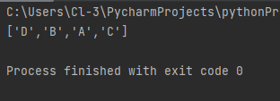

Home Task:
Code:
from queue import Queue
romaniaMap = {
'Arad': ['Sibiu', 'Zerind', 'Timisoara'],
'Zerind': ['Arad', 'Oradea'],
'Oradea': ['Zerind', 'Sibiu'],
'Sibiu': ['Arad', 'Oradea', 'Fagaras', 'Rimnicu'],
'Timisoara': ['Arad', 'Lugoj'],
'Lugoj': ['Timisoara', 'Mehadia'],
'Mehadia': ['Lugoj', 'Drobeta'],
'Drobeta': ['Mehadia', 'Craiova'],
'Craiova': ['Drobeta', 'Rimnicu', 'Pitesti'],
'Rimnicu': ['Sibiu', 'Craiova', 'Pitesti'],
'Fagaras': ['Sibiu', 'Bucharest'],
'Pitesti': ['Rimnicu', 'Craiova', 'Bucharest'],
'Bucharest': ['Fagaras', 'Pitesti', 'Giurgiu', 'Urziceni'],
'Giurgiu': ['Bucharest'],
'Urziceni': ['Bucharest', 'Vaslui', 'Hirsova'],
'Hirsova': ['Urziceni', 'Eforie'],
'Eforie': ['Hirsova'],
'Vaslui': ['Iasi', 'Urziceni'],
'Iasi': ['Vaslui', 'Neamt'],
'Neamt': ['Iasi']
}
def bfs(startingNode, destinationNode):
# For keeping track of what we have visited
visited = {}
# keep track of distance
distance = {}
# parent node of specific graph
parent = {}
bfs_traversal_output = []
# BFS is queue based so using 'Queue' from python built-in
queue = Queue()
# travelling the cities in map
for city in romaniaMap.keys():
# since intially no city is visited so there will be nothing in visited list
visited[city] = False
parent[city] = None
distance[city] = -1
# starting from 'Arad'
startingCity = startingNode
visited[startingCity] = True
distance[startingCity] = 0
queue.put(startingCity)
while not queue.empty():
u = queue.get() # first element of the queue, here it will be 'arad'
bfs_traversal_output.append(u)
# explore the adjust cities adj to 'arad'
for v in romaniaMap[u]:
if not visited[v]:
visited[v] = True
parent[v] = u
distance[v] = distance[u] + 1
queue.put(v)
# reaching our destination city i.e 'bucharest'
g = destinationNode
path = []
while g is not None:
path.append(g)
g = parent[g]
path.reverse()
# printing the path to our destination city
print(path)
# Starting City & Destination City
bfs('Arad', 'Bucharest')

Output:
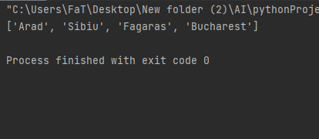

Critical Analysis and Conclusion:
In this lab, I learned about Breadth-First Search (BFS) and Depth-First Search (DFS) algorithms in Python for graph and tree traversal. BFS and DFS are fundamental concepts for Python programmers. I explored BFS, its algorithm, Python code implementation, and its real-world applications, using the example of solving a Rubik's Cube as a graph problem.
BFS involves traversing a graph by dividing its nodes into "Visited" and "Not Visited" categories to avoid cycles. The algorithm starts from a node and explores nodes at increasing distances from the starting point, using a queue to keep track of nodes to be visited. The BFS algorithm can be summarized as follows:
- Begin by placing one of the graph's vertices at the back of the queue.
- Take the front item from the queue and mark it as visited.
- Create a list of adjacent nodes to the current vertex and add unvisited ones to the rear of the queue.
- Repeat steps 2 and 3 until the queue is empty.
- In cases of disconnected graphs, run the BFS algorithm from every unvisited node to ensure all vertices are visited.

